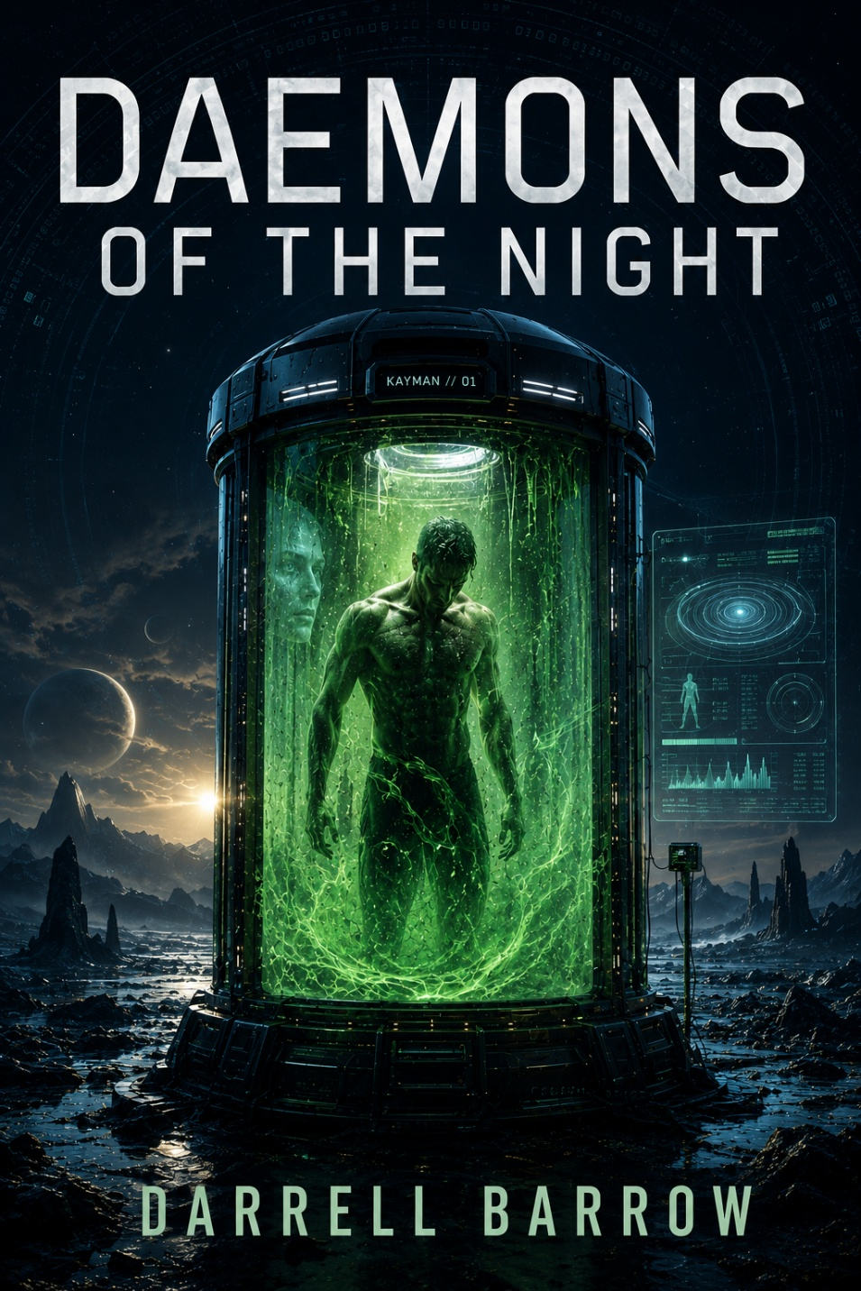

DAEMONS OF THE NIGHT
Darrell Barrow
Barrow Publications © 2000. All Rights Reserved

Contents
Green Goo 5

Green Goo
Kayman woke up to the green, mucus-like liquid in the dimly lit bio tank chamber. He had been in cryogenic sleep for what felt like forever. As the tank started to drain, Kayman felt a rush of energy flowing through his body. He knew it was time to travel through time again.
As the tank completely drained, a ghostly face appeared on the front of the glass. It was the holographic interface that managed the time travel process. Kayman quickly entered the date and location of his destination, and the interface started to hum with energy.
In the distance, Kayman could hear the other biotechs working on the different tanks in the chamber. They were also getting ready to travel through time, each with their destination in mind.
The tank detached from Kayman as he fell forward, but the harness, nutrients, and breathing tubes quickly suspended him. The biotechs began removing the harness and other tubes, wrapping Kayman in a heated blanket.
Once fully recovered, Kayman set out on his mission to uncover the mysteries of the past or potential futures. As one of the rare few capable of traveling through time, he would do whatever it took to protect the timeline and reveal the universe's secrets.
As Kayman's body warmed from the heated blanket, he couldn't help but feel a sense of excitement and anticipation. Every time travel mission was a new adventure with unique challenges and opportunities. He had seen wonders that no one else in his time could imagine, and he relished the chance to explore the vast expanse of time and space.
As the biotechs finished prepping Kayman for his journey, he took a deep breath and stepped out of the chamber. The world around him was a blur of lights and colors as the time travel process began to take hold. He felt disoriented, but he quickly focused his mind and held onto the mission parameters.
When the world around him became clear again, Kayman stood on a barren landscape. The air was thin and dry, and the sun beat down on his skin with relentless heat. He checked his mission briefing and saw that he had reached his destination: a remote planet in the distant past, thousands of years before the rise of human civilization.
Kayman knew he had to act quickly. He swiftly checked his gear and began crossing the landscape, watching the terrain for signs of life or civilization. As he moved, he couldn't shake the feeling that something was watching him, hidden just beyond his sight.
However, Kayman was a talented time traveler who could adapt to new environments and challenges. With each step, he became more confident, focused, and determined to uncover this ancient world's secrets.
And so he pressed on, a fearless explorer in a universe full of wonders and dangers. He was Kayman and would do whatever it took to unlock the mysteries of time and space.
As Kayman crossed the cracked terrain, the dry wind carried faint, broken sounds—whispers that seemed to echo from nowhere. His scanner beeped intermittently, struggling to understand the limited data it collected. Kayman crouched down to examine a cluster of shimmering black stones embedded in the dust, their glossy surfaces reflecting faint, mysterious hues.
Before he could analyze further, his proximity alarm softly blared—a movement signature, small but deliberate, just beyond a jagged ridge to the east.
Kayman straightened, instinctively gripping the pulse emitter strapped to his side. He scanned the horizon, but the source of the disturbance remained elusive. Against the stark, unbroken sunlight, shapes blurred and twisted in the heat haze, but nothing became clear.
He spoke into his comm device, his voice steady, though tension rippled through his chest. “Kayman to Nexus. I have signs of activity and possible life forms. Confirming parameters: this sector should be uninhabited pre-humanity.”
Static responded to him. No reply.
Kayman’s lips tightened into a line. “Nexus, do you read?”
Still nothing.
Adjusting his device to boost the signal, Kayman only caught fragments of Nexus's voice, crackling with interference: "...anomaly detected... proximity… high risk..." The transmission cut off abruptly, leaving a chill despite the relentless heat.
“Great.” Kayman exhaled sharply and put away his comm.
The feeling of being watched grew stronger. He spun around, pulse emitter ready, as a shadow flickered behind him.
“Show yourself!” he called, his voice echoing across the barren landscape. Silence greeted him, but not emptiness. His scanner suddenly detected rapid movement—a swarm-like entity, erratic and fragmented, closing in quickly from multiple directions.
The ridge erupted in a spray of rock and dust as something leaped onto the plateau before him. A creature—if it could be called that—stood there. Its form was translucent and amorphous, a liquid-like membrane rippling as it shifted and pulsed. Within its shifting mass, faint streaks of green glowed, eerily familiar to the bio tank fluid.
Kayman’s pulse quickened as memories resurfaced. The biotechs warned about contamination in the timeline—potential residual effects of extended chrono-shifts. Was this creature a temporal anomaly born from disrupted threads of time?
The entity emitted a deep, resonant hum that shook the ground as it started to move forward.
Kayman took a step back, his mind racing. Every protocol told him to retreat to a safe distance and assess, but his instincts urged him to do otherwise. He tightened his grip on the pulse emitter, aiming for the glowing streaks. “If you’re out of time,” he muttered, “I’m putting you back where you belong.”

